Selenium Questions
1. What are XPath and its types?
Xpath is a type of locator finding strategy in the web application. There are 2 types of xpath
- Absolute xpath – [traversing from root tag to desired tag]
- Relative Xpath - [traversing from the required tag]
What are cross-browser testing and parallel testing?
- Cross Browser Testing is nothing but testing the application in different browsers like – chrome, firefox, edge , ect.
- Parallel Testing is nothing but running multiple test scripts simultaneously is called parallel testing.
How to perform (control + a) through selenium?
We can achieve this action by using Robot class
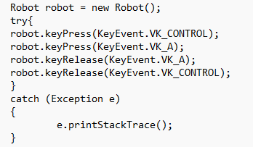

How to shift between tabs of the same browser using selenium?
In order to shift between tabs this is the program
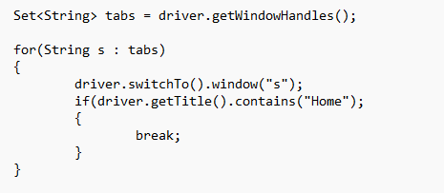

What is a Robot class?
Robot class is used to perform keyboard actions. We have methods like keyPress() and keyRelease() method.
What is AutoIT?
- Tool which is used to automate windows graphical user Interface tasks, such as automating keyStrokes, mouse movement, window manipulation and executing programs.
What is POM? Advantage and its disadvantage?
- POM stands for Page Object Model, POM is a design pattern used primarily in Web automation
- Advantages
  - Improved maintenance – Storing the elements of a page in a single class will help in maintaining the elements. If any UI changes happen, easily we can update that in a single place.
  - Reusability– allows to re-use the code between the test cases.
- Disadvantages
  - Increased Complexity – Using POM we have to create a separate class for each page and have to main
  - Increased setup time – Setting up POM pages can be more time consuming.

How to verify ‘Bangalore’ present in the dropdown box or not?
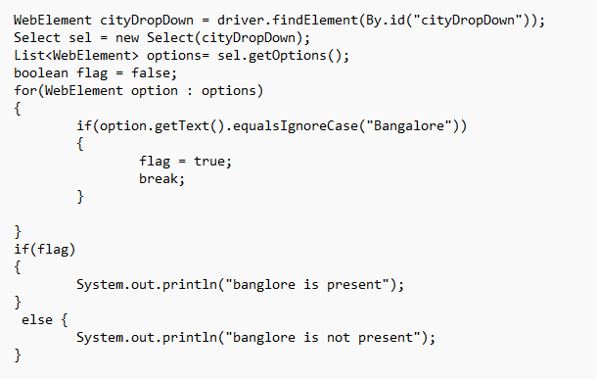
Explain the tags present in the testng.xml file
- < suite> - suite tag is the root tag which descripts which suite it is whether we can declare this suite as regression, smoke , ect…
- <test> - test tag represents a test within a test suite.
- <classes> - tag groups together multiple test classes to be included in a test.
- <class> - tag specifies the fully qualified name of a test class.
- <methods> - tag groups together multiple test methods to be included in a test.
- <include> - tag specifies the name of a test method to be included in a test.
- <exclude> - tag specifies the name of a test method to be excluded from a test.

How to pass values to textbox other than using sendKeys()?
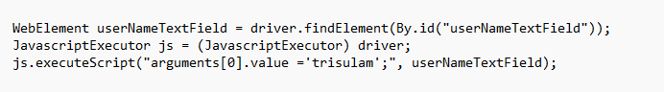

Java Questions
Do You know String and where you have used and do you know few inbuilt methods of strings and where you have used and how and in which scenarios you have used?
Yes, String is a collection of characters where String class is an immutable class which has some in-build methods like length(), concat(), substring(), toCharArray(), toLowerCase(), toUpperCase(). To make dynamic xpath we have made used of String.format(text, xpath);
Have you used collection in your projects?
- Yes, To fetch the data from properties file we used HashMap.
- If we have Multiple web elements we use to store it in List<WebElement>
- If we have Multiple windows we used
In method overloading can we given different type of datatypes as a input?
- Yes, we can declare multiple methods with the same name and it can be differ by the arguments by type, size, and position of the input arguments. In that way we can overload methods by giving different types of datatypes as input arguments.
Method Overriding? and where you have used?
- Method overriding is nothing but providing the method name same as super class and changing its implementation in the sub class is called as method overriding.
- Is-A relationship is mandatory to override
- Static members cannot be overridden.
Where and how you implemented OOPS concepts in your framework?
- Inheritance – Every test class is extended by TestBase where we specify the configuration annotations.
- Encapsulation – in POM (Page Object Model) design pattern we used encapsulation by declaring the data members as private and utilizing them by providing getters and setters.
- Polymorphism –
  - compileTimePolymorphism – Method Overloading – In Element class getText() method which will take different kind of arguments either by WebElement or It will Take String xpath.
  - RunTimePolymorphism – Method Overriding – Methods in the Static Data base is overridden in StaticDataBaseEn class.
- Abstraction – Hiding the implementation showing only the behavior of an object is called abstraction.
What is List and Set ? AND Difference between both of them?
- LIST
  - Default capacity is 10
  - Insertion order will be maintained
  - Allows duplicates
  - Allows numerous ‘null’ values
  - List is implemented by ArrayList, LinkedList, and Vector
- SET
  - Default capacity is 16
  - Insertion order is not maintained
  - Doesn’t allows duplicates
  - Allows only one null value
  - Set is implemented by HashSet, TreeSet

Have you used Try , catch and do we have other exception handling in java?
- Yes, if JVM encounters any risky line of code , at that time an Object is created called Exception. To handle this exception we can use try catch. Also we can handle checked exceptions using ‘throws’ keyword in the method declaration.
Can we keep Constructor Private and Public and explain why?
- We can keep constructor as public but not private. Main moto of a constructor is to initialize the non static elements when we declare constructor as private we cannot able to initialize the non-static members of that particular class.
Explain Constructor and where you have used that?Constructor Overloading?
- Constructor is a special type of method where it is used to initialize the non-static members of a Class. In my project we have used constructor to initialize the web Elements in the POM page.
- Constructor Overloading is a concept where we can define multiple Constructors in the same but the Parameters should vary.

Difference between equals() and ==
- equals() method will compare the contents present in the Object.
We can compare values of an Object type.
- double equals operator (==) is used to compare whether two objects references points to the same memory location.
We can compare the primitive type like int, char, ect.

